Information
for travelers with
dog, cat, ferret
The animal which is entered into the EU territory must have:
- AN INDIVIDUAL IDENTIFICATION
- A VALID ANIT-RABIES VACCINATION
- A NEUTRALIZING ANTIBODY TITRATION TEST *
* in case of travel from third countries not mentioned in Annex II of Regulation (EU) No 577/2013
The identification document of the animal is the EU PASSPORT properly and completely filled before leaving the EU territory or the HEALTH CERTIFICATE issued by an official veterinarian or by an authorized veterinarian and endorsed by the competent authority of third country.
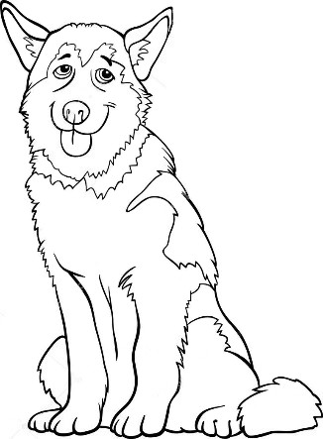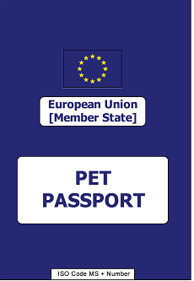
Detailed information is available on the website
General Veterinary Inspectorate:
www.wetgiw.gov.pl in section: Podróże ze zwierzętami towarzyszącymi

